
PHP based development of an Online collectable items marketplace
Section 1

Development of an Online collectable items marketplace using modern practices of SDLC and Web Technologies
Name | Registration Number
Arshdeep Singh | 19BCB0086
Arpit Khandelwal | 19BCE0888
Nirzar Purvang Modi | 19BCE2291
Shubh Almal | 19BCE2130

Abstract
This research paper is intended to study and implement the development of a PHP based system of an online collectable items marketplace which can onboard multiple users and sellers while keeping a singular admin account. The research intensely focuses on adapting modern techniques of the SDLC (software development lifecycle), Pattern matching algorithms to optimize search times, secure multilayer encryption techniques for login and purchase modules, overall security from XSS attacks in the input fields while documenting the work and meanwhile proposing a system with a rich feature set to satisfy user requirements
© 1905 Elsevier Science. All rights reserved

- Keywords: Algorithms ; Pattern Matching ; Software Development ; Modular design ; Encryption ; XSS attacks ; Features ; Marketplace modelIntroduction
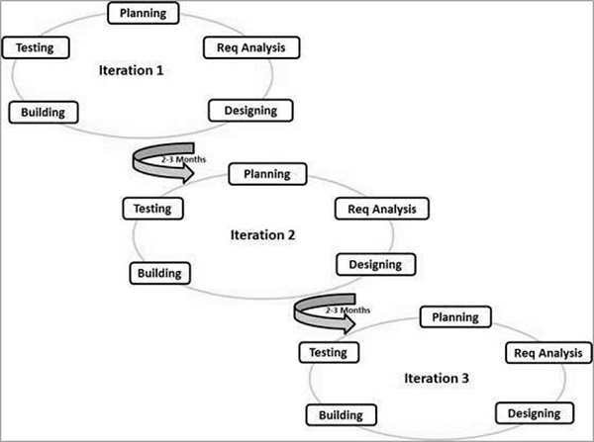
Web Development is a widely popular domain for development of ideas and materializing them into real world applications. However, with the advancement of computer science many modern approaches must be put to practice in order to achieve desired results. The motivation to develop an online antique marketplace is explained briefly. Firstly, According to IBIS World, the antiques and collectibles sales industry has grown over the past 5 years by 7.2%. In the year 2018 it reached a revenue of 2 billion USD, parallelly the business has grown by 1.3% and employees’ number has grown by almost 1% (as of 28th July 2019). Secondly, as per reports from AT&T the global internet usage for purchase has dramatically increased and makes it all the more essential for businesses to adopt such means to stay afloat. Thirdly, in order to dive more into security and encryption-based techniques the system must involve components like payments and login systems which can be tested at a big scale. Lastly, the desire for speed and responsiveness must be satisfied and in order to do so the development of such an application must involve a rich feature set and improved search times. In order to effectively do so we must delve into the domain of pattern searching algorithms.
On the whole this research is a collaborative effort that lets us understand the modern practices of software development and how new ideas can be brought about in the lifecycle of the Web application we plan to build. Essentially this research provides a simulation to all considerations for modern software development.
The problem we aim to deal with involves the top-down approach of software development wherein the working components are made in a way that they simply tend to work and later refactoring the components and developing documentation so that others can collaborate. This approach works and with a good skillset it is possible to achieve desired results. However, we plan to explore multiple domains as effectively as possible and in order to do so we shall follow a bottom-up approach of Software Development which involves researching the problems in the respective domains and then collaboratively working on the applications which results in simultaneous development, collaboration and documentation of the work at hand.
The objectives of this application shall follow a set of primary goals which have been subsequently discussed. Firstly, the app must have a modular design and must address all the features that have been discussed so far. This involves the identification of roles (such as user can edit profile, onboard, search categorically, filter results etc.) and implementing them in the modules that they concern. Secondly once the identified features are being developed there must be identification of the novelties that need to be embedded into the system. In our case, the modules concerning login and payment must be encrypted with the researched algorithms while the modules involving product searching must be embedded with the algorithms involving pattern matching. The overall system must be made highly interconnected so that future developments and maintenance is easily achieved. In our case that would involve making the web-pages dynamically adjust their behavior as per the real-time changes made by the multiple entities to the database.
In order to develop the application many techniques had been researched involving modern SDLC and in order to suit our means we had to select
among many of the present SDLC models. However, our SDLC hybridizes multiple SDLC’s such as agile
Agile Development
* Courtesy tutorialspoint.com

development model alongside with the classical waterfall model. The waterfall model provided us the needed stability for the development of the backbone while the agile development was embedded into the modules where the revised algorithms were needed to be tested multiple times. Multiple proposals were made for the concerned algorithms and will be discussed further into the paper.

PHP based development of an Online collectable items marketplace
Section 2

- Literature Survey
This section is made with the intention to discuss all the material that has been taken into consideration while making this document.

Table 1 – Literature survey on SDLC

Sno. | Title of research | Conclusions | Research Gaps
1 | A Study of Importance of UML diagrams: With Special Reference to Very Large-sized Projects - 2013 | - Introduces all standard techniques used for UML diagrams  - Properly discusses the various scenarios where the techniques can be used | - Sticks to standard rules only  - Does not discuss how hybridization can take place  - Poorly describes the other steps of development
2 | WATERFALL Vs V-MODEL Vs AGILE: A COMPARATIVE STUDY ON SDLC - 2012 | - Describes in detail the scenarios where each technique is useful  - Provides a basis on which further research of Agile model and Waterfall model was chosen | - Only sticks to the standard rules as defined and no room for cherry picking  - Involves many steps which may not be needed for a small scale and is only useful for large scale systemwide development
3 | The Database Normalization Theory and the Theory of Normalized Systems: Finding a Common Ground - 2016 | - Provides us a scaffold for making an efficient database design  - Normalized database crucial for system | - Had to work on the data that must be captured and useful on our own basis  - Poorly addressed which normalization level is effective for which scenario
4 | A Review Paper on Human Computer Interaction - 2018 | - Review paper perfectly discusses modern HCI practices  - Provides all insights to improvise UI for optimal frontend development | - Lacks implementation details  - Frontend needs to adapt to functionality  - Involves user interaction to be effective

Table 2 – Literature Survey on XSS attacks

Sno. | Title of research | Conclusions | Research Gaps
1 | Statically Identifying XSS using Deep Learning - 2021 | - Static approach to detect XSS vulnerabilities using neural networks were explored  - The neural network models not only work for XSS vulnerabilities but also for different security vulnerabilities like CSRF, DOM-XSS, etc. | - The database always has some missing data which can disrupt the model for giving proper results  - There might be real cases which couldn't be examined or were not represented in the files which were analysed.
2 | Server-Side Method to Detect and Prevent Stored XSS Attack - 2021 | - A method to detect and prevent the reflected-XSS attack was proposed. In this type of attack the injected script is stored inside the vulnerable webpage and harms every user who visits the vulnerable webpage.  - All scripts that may cause harm or cause vulnerabilities are filtered and deleted by the proposed method | - Reflected-XSS are not detected and prevented  - Second Factor Authentication for PSS is not available and possibility of replay of the same vulnerability is not avoided.
3 | Cross-Site Scripting Guardian: A Static XSS Detector Based on Data Stream Input-Output Association Mining - 2020 | - “Cross-Site Scripting Guardian”, an approach to detect XSS vulnerabilities in PHP code based on ML was introduced in this paper.  - In this experiment on the test dataset, the recall rate for vulnerability samples is as high as 98% which also shows importance of learning the importance of opcode sequence and pattern of input-output in the data stream | - The impact on more complex data flow could not be examined due to limited data flow sources  - Some hard-to-find vulnerabilities have multiple execution branches which were difficult to be explored by the Machine Learning model.
4 | XSS Attack Prevention Using DOM based filtering API - 2014 | - The proposed filtering API filters the server response rather than user input which gives more insight in attach mitigation  - The proposed method requires less modification at server applications which is not a burden to the web developer | - Mitigation against DOM based (client side) XSS attack is not provided  - Other strong methods used to prevent XSS attacks are not discussed.
5 | Automated Discovery of JavaScript Code Injection Attacks in PHP Web Applications - 2015 | - Automated detection system, which scans the possible injection locations for the XSS vulnerabilities is proposed in this paper  - The evaluation results showed that our system discovers the XSS vulnerabilities on the Blog It PHP web application with acceptable runtime overhead. | - Detection of DOM-based XSS vulnerabilities could not be anticipated using the approach discussed in this paper.
6 | On Security Issues in Web Applications through Cross Site Scripting (XSS) - 2013 | - A study to consolidate the understanding of XSS, their origin and manifestation, kinds of dangers and mitigation efforts for XSS, is presented in this work. | - Not all the types of XSS attacks were covered in this paper leaving a huge gap.

Table 3 – Literature Survey on pattern matching Algorithms

Sno. | Title of research | Conclusions | Research Gaps
1 | Study of Different Algorithms for Pattern Matching - 2013 | - Provides accurate information on various algorithms which are suitable for pattern matching  - Algorithms used are far superior to basic methods and don’t have limitations of size of data or accuracy | - The algorithms discussed are robust and may not be required for quick usage.  - Algorithms are non-intuitive and may take more time than basic algorithms for small-scale data.
2 | PATTERN MATCHING ALGORITHMS FOR RETRIEVING INFORMATION FROM WEB DOCUMENTS -2016 | - Very apt for the implementation  - Satisfies user requirements  - Aptly discusses various means to do so | - Plan to improvise on the existing algorithm to offer real time suggestions  - Intuitive application of underlying algorithms

Table 4 – Literature survey on online marketplaces
Sno. | Title of research | Conclusions | Research Gaps / Our proposals
1 | Analysing, Designing and Implementing a Web-Based Auction online System -- 2019 | - Provides us useful system design  - Introduces important web-based architectures | - Improve upon the User Interface as the given one in the paper is poor  - Integration into a detailed system for practicality.
2 | An Architecture of E-Marketplace Platform for Agribusiness in Indonesia -- 2020 | - Detailed explanation of the model  - Good insights on database design | - It can be implemented more effectively with better categorical approach  - Must be altered to suit our application.

Table 5 – Literature survey on encryption techniques
Sno. | Title of research | Conclusions | Research Gaps
1. | Secure login by using One-time Password authentication based on MD5 Hash encrypted SMS -2013 | - Complete understanding of MD5 approach to encryption  - Implementation is appropriately discussed | - Restricted to MD5 only which has now been cracked and can be reversed  - A very particular use case is being discussed and its embodiment into different scenarios is absent
2 | Secure Login for Web-Based Embedded Systems - 2012 | - Proper implementation details have been discussed  - Satisfies the security levels expected from large scale systems | - The model needs to be altered for our system design as the approach focuses on embedded systems  - Lack of insight as to how customisations can be done for different scenarios
3. | Secure Login System for Online Transaction Using Two Layer Authentication Protocol -2020 | - Uses new and improvised algorithms to suit current day scenarios  - Provides insight to creation of robust protocols with multiple layers of security | - We propose to use the layout of this paper but plan to implement different algorithms so as to create newer and potentially more useful algorithms
4 | Storage less Credentials and Secure Login - 2016 | - Very complex and high level of authentication is used  - Provides an almost uncrackable system to work with | - Due to algorithmic approaches to authentication the load on the server is increased  - Maintenance/Development of such a system requires high skill
5. | A secure login method based on typing pattern -2019 | - Proposes a new pattern-based encryption algorithm  - Relatively novel and irreversible | - Implementation details seem to be absent  - This helped us to infuse a small-scale hybridized algorithm for our system usage

Table 6 – Literature survey on SQL injection

Sno. | Title of research | Conclusions | Research Gaps
1 | A STUDY ON SQL INJECTION TECHNIQUES - 2016 | - Various prevention and detection mechanisms were discussed which were used before and after the year 2011.  - Various SQL injection attack types were discussed with their purpose and the command through which the attack happens. | - Despite the advancement in technology, SQL injection attacks still take place
2 | Analysis of SQL Injection Detection Techniques | - In this paper different types of modern SQL injection attacks were discussed which are less known.  - The SQL attacks discussed in this paper are quite complex as compared to the classical SQL injection attack. | - Since these attacks are not much known to the researchers as well there is very little information regarding them.  - The prevention and detection techniques are very less for these type of SQL attacks
3 | STUDY ON SQL INJECTION ATTACKS: MODE, DETECTION AND PREVENTION  International Journal of Engineering Applied Sciences and Technology, 2016 Vol. 1, Issue 8, ISSN No. 2455-2143, Pages 23-29 | - In this paper different strategies to change over SQL query into number of helpful tokens by applying tokenization was discussed  - AES algorithm is used to avoid SQL injection attack | - SQL query change plan is still required.  - Requires integration into a detailed system for practicality.
4 | Detection and Prevention of SQL Injection Attack: A Survey  Zainab S. Alwan et al, International Journal of Computer Science and Mobile Computing, Vol.6 Issue.8, August- 2017, pg. 5-17 | - In this paper a survey report is presented on the classical and modern types of SQLIA.  - The detection and prevention techniques are compared based on their ability to detect and prevent the attack | - There are a few techniques which needs improvement to overcome SQLIA
5 | A novel technique to prevent SQL injection and cross-site scripting attacks using Knuth-Morris-Pratt string match algorithm  EURASIP Journal on Information Security volume 2020, Article number: 14 (2020) | - In this paper a novel approach to detect and prevent SQL injection is presented in this paper.  - The proposed technique was successful in detecting and preventing all the attacks | - Need to find a way to embed into our proposed project
6 | SQL injection attack Detection using SVM  International Journal of Computer Applications (0975 – 8887) Volume 42– No.13, March 2012 | - In this paper a secure application is provided based on classification of original and suspicious query strings using SVM (Support Vector Machine)  - Accuracy is 96.47% which is the best among the current existing systems | - SVM is not supported for large data sets.  - SVM doesn’t perform well when target classes are overlapping

PHP based development of an Online collectable items marketplace
Section 3

- Proposed Work
After the entire literature analysis, we can finally start to discuss in detail about all the work we propose to do. In the process of the development, we also used many standard techniques like development of UML specified diagrams to carry out the process in an appropriate manner.
  - Expected features
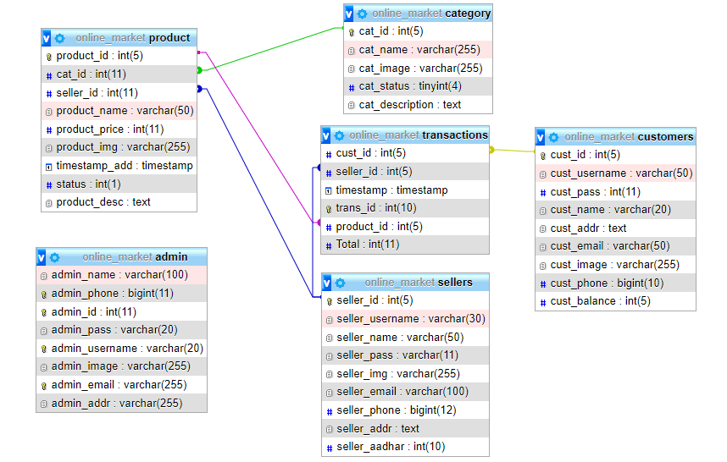
The development process involves many detailed steps and shall not be discussed entirely through words. Instead, we can claim that there was a total of 25 usable features that were identified and implemented among 3 modules (User, Seller and Admin). Now upon detailed analysis of encryption algorithms and the provided feature set which already exists in PHP, we used a combination of SHA encryption algorithms with MD5 so as to provide the system with a double encrypted security. Strong contenders for the encryption algorithms included salt which had a key value-based approach of encryption and provided much better security that each of the algorithms discussed so far. This algorithm however on its own is very capable it consumed a lot of time to encrypt the strings and thus in comparison the dual encryption technology fared better. The need for this encryption technology is expected to be used in the login and onboarding functionalities of the application.
The application also aims to use session-based login system mainly because although it is possible to develop a cookie-based system, the session-based login system makes the user experience far more natural. Furthermore, developers ultimately need to rely on both session and cookies which complicates the code and hence development is simplified by using such a technique. Lastly, the shortcomings of the session-based login system are compensated by the usage of encryption algorithms.
  - Architectural definition (entity level)
The Entity diagram illustrated below rightfully explains the overall architechture of the system that we plan to build.The working entities and components are described in detail and as one tries to implement the system the need for each component is apparent.
Every component has a specific datatype which is supported by MySQL as of the development of this document and every component has its relation/function specified on the connecting lines of the component which illustrates the functional dependancy amongst the working entities

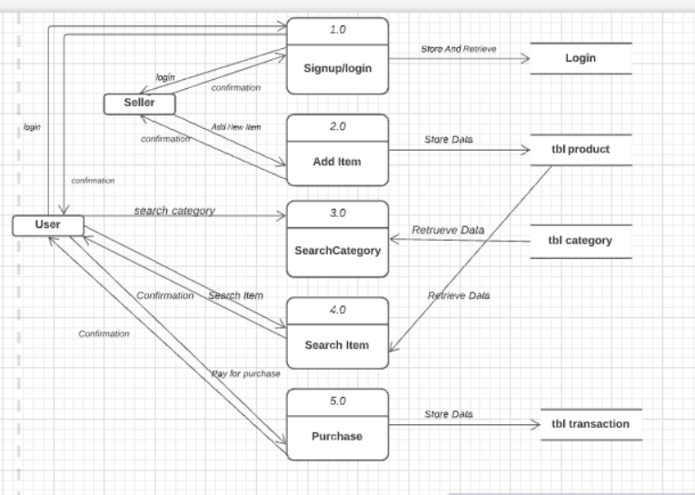

  - Architectural definition (Modular level)
The following diagram relates the functions of each entity with their respective components of the system. The image below represents a data-flow diagram and uses UML specifications to represent entities, functions, data involved and the table concerned for the particular usage.

  - Architectural definition (High level)
The high-level abstracted version of the system can be represented with the following diagram. The tools used are just for representation but ultimately depend on the developer and what all resources are available at that moment.

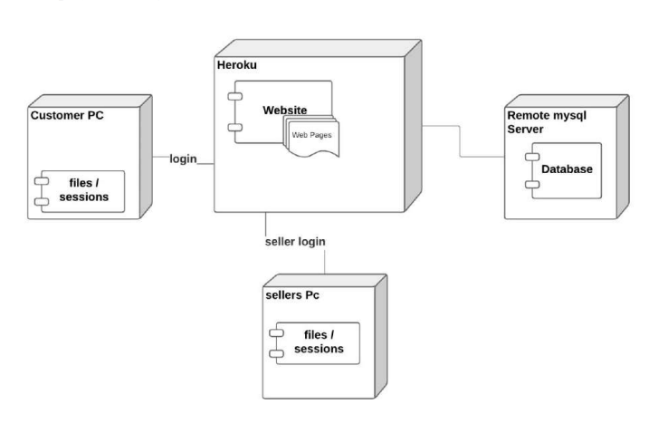

BLOCK-DIAGRAM REPRESENTATION

In order to prevent confusion/ files/sessions represent only the fact that sessions are initiated based on actions executed by the client side machines ,while sessions originally function on the server only.Furthermore files in this case represent the pictures in all accepted formats for purposes like user profile picture, product image representations etc.

  - Techniques employed for XSS prevention
As per the research we conclude to implement some of the robust ways to prevent XSS attacks. Firstly, any input accepted from the user is accepted through HTML forms and thus every form must be validated at the backend so as to keep the system more secure. Secondly, all SQL queries are to be executed in atomic transactions so as to keep the database consistent. Thirdly, the form input must always be striped off from any scripting tags such as PHP scripts, SQL scripts and JS scripts. This technique provides a great deal of prevention from most XSS attacks.
The system also ensures a token for login and redirects all external requests to the login page which discards the requests. This completely prevents access of inner pages of the website without login and since the login is secured with double encryption the sensitive information is secured.
Due to the modular nature of the web application the database connection token is stored away securely and even in case of database corruption the connection token can quickly be redirected to a Data Backup thus ensuring the systems reliability.
A reliable way to prevent malicious content from entering into the system to use a standard text encoding technique by explicitly specifying it in the code base. This ensures that all the data is displayed in a consistent fashion throughout the system.

  - Techniques employed for pattern-matching
Searching is an essential feature used on a frequent basis for filtering data based on their name or category. While categorical filtering can be done using the database, the searching functionality must be implemented in the Client-Side only as the Client may request for multiple kinds of information. The simplest principle of searching involves simple matching of all characters of the string. However, such a rudimentary form of pattern matching is poor. Thus, the better way of handling this is to search for patterns that resemble the text and sort based on similarity of the search. This provides us with a more insightful representation of the data. The current algorithms used involve complex pattern matching algorithms like KMP (Knuth Morris Pratt) pattern matching algorithms. However, the way a user intends to search the information tends to resemble pattern matching techniques similar to sliding window. Thus, in order to satiate the needs of the user we tend to incline ourselves to a faster technique while limiting the behavior to the point where the user is able to obtain the desired results.

- Results and Outputs

PHP based development of an Online collectable items marketplace
Section 4

PHP based development of an Online collectable items marketplace
Section 5 & 6

- Conclusion
In our research paper, we have been successful in developing a PHP based system. This system is an online marketplace. The marketplace is built to provide users with a medium to purchase and sell collectable items. The facility for multiple users and sellers to buy and sell collectables and antiques using a single admin account has been provided in our system.
We have focused our attention mainly on adding modern and new efficient techniques to the online marketplace which has been built. Techniques like SDLC (software development lifecycle) and Pattern matching Algorithm have been used and implemented which has the potential of optimizing search time for the users. Multilayer encryption has also been used to maintain security for login and purchase modules. Not only that, but the multilayer encryption also provides security from XSS attacks.
Thus, we conclude that our online marketplace is a well-built platform that is a user friendly and secure place for buying and selling antiques and collectables.
- Future Scope
Going forward, we can see our product being the handiest and the go-to website for antique collecting enthusiasts. As you can see on our website, we have features such as
- The seller has a separate account where he can put up items for sale and their respective prices.
- Also you have a buyers account from where the buyer can easily buy and view various types of products.

We see our product as an absolute win where we can buy antiques and collectables by sitting within the comfort of our homes and buying is just one click away. We see our product as a huge success going forward in the future since we all know “time is money” and our website makes buying very efficient and without any wastage of time compared to the typical offline auctions where you have to specifically go to the place to buy the item you want and still there is no guarantee of you acquiring that product.
- We also aim to have very smooth logistics for the buyers where there is transparency between them and the sellers using our website.
- We also aim to have a real-time tracking system of the product so that the buyer knows which process their product is going through and when they can expect the product delivery.
- We also aim to have a detailed description of our products wherein the buyer states which century the product is from and its historic importance and to whom it belongs.
- As we all know the crypto market is booming massively in the current scenario, we also aim to accept payments through cryptocurrency.
- References
- Abikoye, O. C., Abubakar, A., Dokoro, A. H., Akande, O. N., & Kayode, A. A. (2020). A novel technique to prevent SQL injection and cross-site scripting attacks using Knuth-Morris-Pratt string match algorithm. EURASIP Journal on Information Security, 2020(1). https://doi.org/10.1186/s13635-020-00113-y
- Aldaej, R., Alfowzan, L., Alhashem, R., Alsmadi, M., Al-Marashdeh, I., Badawi, U., Alshabanah, M., Alrajhi, D., & Tayfour, M. (2018). Analyzing, Designing and Implementing a Web-Based Auction online System. International Journal of Applied Engineering Research, 13, 8005–8013. https://www.ripublication.com/ijaer18/ijaerv13n10_102.pdf
- Balaji, S., & Sundararajan, M. (2012). International Journal of Information Technology and Business Management WATEERFALLVs V-MODEL Vs AGILE: A COMPARATIVE STUDY ON SDLC. International Journal of Information Technology and Business Management, 2(1). https://mediaweb.saintleo.edu/Courses/COM430/M2Readings/WATEERFALLVs%20V-MODEL%20Vs%20AGILE%20A%20COMPARATIVE%20STUDY%20ON%20SDLC.pdf
- Bansal, H., & Khan, R. (2018). A Review Paper on Human Computer Interaction. International Journal of Advanced Research in Computer Science and Software Engineering, 8(4), 53. https://doi.org/10.23956/ijarcsse.v8i4.630
- Devi, R., Venkatesan, R., & Koteeswaran, R. (2016). A study on SQL injection techniques. https://www.researchgate.net/publication/316886377_A_study_on_SQL_injection_techniques
- Dinesh, S. (2014). XSS Attack Prevention Using DOM based filtering API. https://core.ac.uk/download/pdf/53189097.pdf
- Eessaar, Erki. (2016). The Database Normalization Theory and the Theory of Normalized Systems: Finding a Common Ground - ProQuest. Www.proquest.com. https://www.proquest.com/openview/5bb937212fd69995536758e0680f1350/1?pq-origsite=gscholar&cbl=2040245
- Gupta, S., & Gupta, B. B. (2015). XSS-SAFE: A Server-Side Approach to Detect and Mitigate Cross-Site Scripting (XSS) Attacks in JavaScript Code. Arabian Journal for Science and Engineering, 41(3), 897–920. https://doi.org/10.1007/s13369-015-1891-7
- Gupta, S., & Gupta, B. B. (2016). Automated Discovery of JavaScript Code Injection Attacks in PHP Web Applications. Procedia Computer Science, 78, 82–87. https://doi.org/10.1016/j.procs.2016.02.014
- Haque, M. A., Zia Khan, N., & Khatoon, G. (2019). Communication and Computing Systems. CRC Press. https://doi.org/10.1201/9780429444272
- Kumar, B., & Yadav, S. (2016). Storageless Credentials And Secure Login. Proceedings of the Second International Conference on Information and Communication Technology for Competitive Strategies - ICTCS ’16. https://doi.org/10.1145/2905055.2905113
- Li, C., Wang, Y., Miao, C., & Huang, C. (2020). Cross-Site Scripting Guardian: A Static XSS Detector Based on Data Stream Input-Output Association Mining. Applied Sciences, 10(14), 4740. https://doi.org/10.3390/app10144740
- Malviya, V. K., Saurav, S., & Gupta, A. (2013, December 1). On Security Issues in Web Applications through Cross Site Scripting (XSS). IEEE Xplore. https://doi.org/10.1109/APSEC.2013.85
- Maurel, H., Vidal, S., & Rezk, T. (2021). Statically Identifying XSS using Deep Learning Statically Identifying XSS using Deep Learning. https://hal.inria.fr/hal-03273564/document
- Piantari, E., Ashaury, H., Junaeti, E., & Nagalla, V. (2020). An Architecture of E-Marketplace Platform for Agribusiness in Indonesia. Proceedings of the Proceedings of the 7th Mathematics, Science, and Computer Science Education International Seminar, MSCEIS 2019, 12 October 2019, Bandung, West Java, Indonesia. https://doi.org/10.4108/eai.12-10-2019.2296542
- Qu, B. (2012). Secure Login for Web-Based Embedded Systems. Communications in Computer and Information Science, 640–647. https://doi.org/10.1007/978-3-642-31965-5_75
- Rahul Diwate. (2013, March 11). Study of Different Algorithms for Pattern Matching. ResearchGate; unknown. https://www.researchgate.net/publication/282652139_Study_of_Different_Algorithms_for_Pattern_Matching
- Rawat, R., & Kumar Shrivastav, S. (2012). SQL injection attack Detection using SVM. International Journal of Computer Applications, 42(13), 1–4. https://doi.org/10.5120/5749-7043
- Sediyono, E., Santoso, K. I., & Suhartono. (2013). Secure login by using One-time Password authentication based on MD5 Hash encrypted SMS. 2013 International Conference on Advances in Computing, Communications and Informatics (ICACCI). https://doi.org/10.1109/icacci.2013.6637420
- Singh, J. P. (2017). Analysis of SQL Injection Detection Techniques. Theoretical and Applied Informatics, 28(1&2), 37–55. https://doi.org/10.20904/281-2037
- Sinha, S. (2020). Secure Login System for Online Transaction Using Two Layer Authentication Protocol.
- Som, S. (2016). STUDY ON SQL INJECTION ATTACKS: MODE, DETECTION AND PREVENTION.
- Vijayarani, M. (2016). PATTERN MATCHING ALGORITHMS FOR RETRIEVING INFORMATION FROM WEB DOCUMENTS.
- Waykar, Y. (2013, March). (PDF) “Importance of UML Diagrams in Software Development.” ResearchGate. https://www.researchgate.net/publication/322991992_Importance_of_UML_Diagrams_in_Software_Development
- Zainab, S., & Alwan. (2017). Detection and Prevention of SQL Injection Attack: A Survey. International Journal of Computer Science and Mobile Computing, 6(8), 5–17. https://www.ijcsmc.com/docs/papers/August2017/V6I8201701.pdf

